**Exercise 2:**

1. 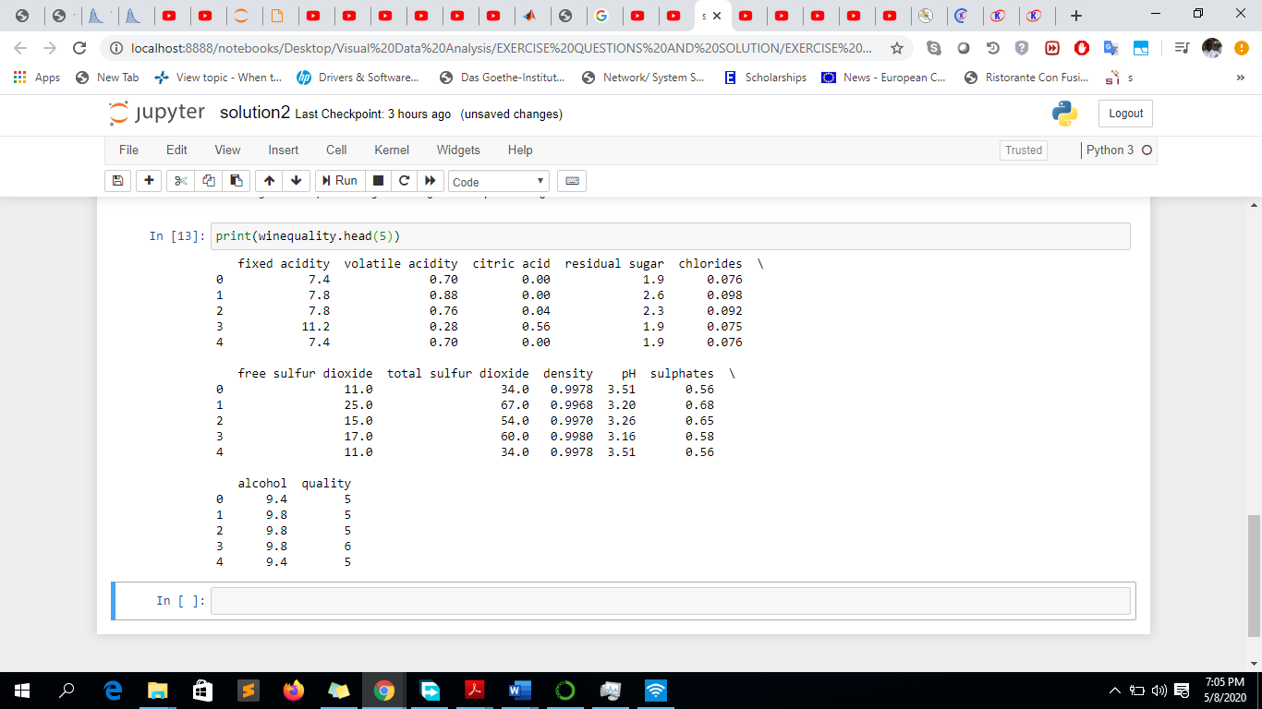
2. **Range is from 3 – 8.**

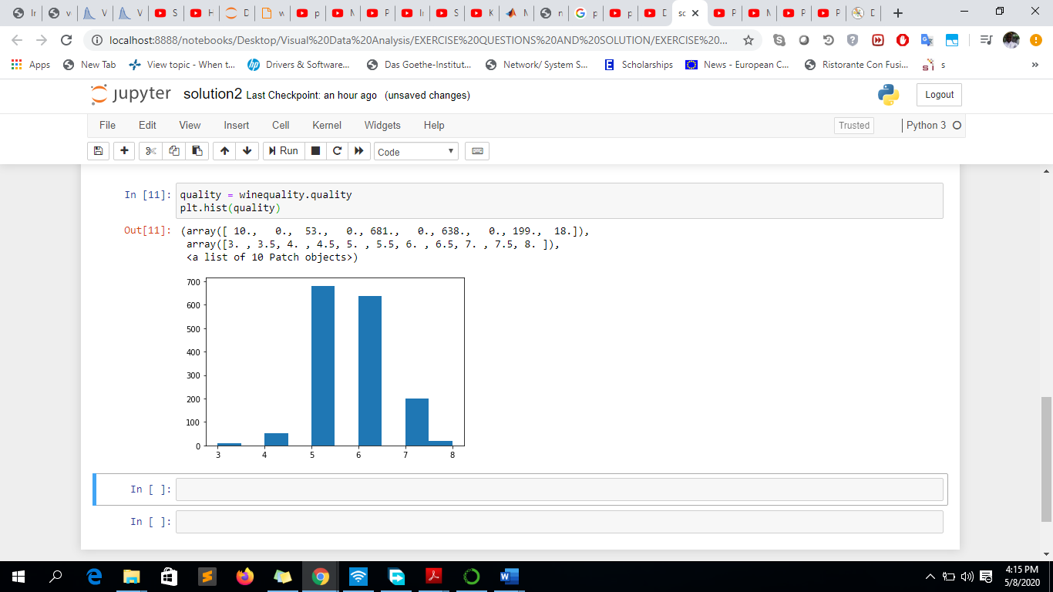

**Exercise 3 (Evaluating PCP Variants):**

1. **In addition to standard PCPs, the authors test eight variations. For each of them,** **briefly describe the proposed modification, and** **why the authors expected it to improve the visualization. Use 1-2 sentences for each of the eight cases.**
2. **Scattered Plots embedded into PCP (SP):**

**Proposed Modification:** As an alternative to implementing a k x k scatter plot matrix for k dimensional data to provide a 2D (Two Dimension) scatter plot for each data variable combination, the authors embedded 2D scatter plots between each pair of adjacent axes.

**Why?:** The modification saved screen space and still provided a 2D scatter plot for each pair of adjacent axes as defined by the PCP axes ordering and axis labels were able to be distributed effectively by rotating the scatter plots by 45 degree.

1. **Density Based Coloring (Color):**

**Proposed Modification:** The use of Color and Opacity-based highlighting method for fuzzy clusters using the local neighborhood density of each data point.

**Why?:** The authors expected that the modification will maximize the number of distinct, smoothly interpolated colors to facilitate cluster discrimination and not necessarily to show order.

1. **Density Based Blending (Blend):**

**Proposed modification:** For the amount of enhancement in the visualization, the authors used ei = 0.25 and ei = 1, mapped to a minimum and maximum opacity multiplication factor in order to control the polyline opacity.

**Why?:** In order to control polyline opacity and increase visibility of polylines in the visualization.

1. **Combination of Density-based Coloring and Blending (ColorBlend):**

**Proposed modification:** Combination of the Density based coloring and Density based blending variations.

**Why?:** Toincrease visibility of polylines in the visualization.

1. **PCP using Curves intend of polylines (Curves):**

**Proposed modification:** Theuse of a curve drawing method that resolves crossing ambiguity by only introducing curvature where needed.

**Why?:** To ease visual tracking of data points across the data variables.

1. **Random tour animation (Animation):**

**Proposed modification:** The use of parallax motion cues that could facilitate cluster detection and results in polyline clusters that move fast enough to quickly create parallax while still enabling viewers to visually track them.

**Why?:** It generates animations that are virtually non-cyclic and always showing new patterns.

1. **Permutation tour animation:**

**Proposed modification:** The authors modified Wegman’s animation scheme which showed that, for k-dimensional data, the minimal set P of PCP axis permutations necessary so that every possible axis adjacency occurs contains (k + k mod 2) = 2 permutations; by smoothly cycling through all of these permutations, showing viewers all possible axis adjacencies in an animated fashion.

**Why?:** The author expected that the average on-screen animation speed of the polylines matched that of the random tour scheme

1. **Wobble Animation:**

**Proposed modification:** The use of PCP polylines that “wobble” (oscillates) around a fixed base position in a sinusoidal way.

**Why?:** The author expects that this will help to generates helpful motion parallax, but keeps clusters fairly fixed, and thereby ease visual tracking.

1. **Within the user study, what task did the subjects have to perform? Name another task for which Parallel Coordinates are frequently used in practice, but which was not included in the study.**

**Answer:** The participants were told to count clusters (“ribbons”) using PCP variations after the concept of PCP was introduced to the participants.

PCP is used in [collision avoidance algorithms](https://en.wikipedia.org/wiki/Traffic_collision_avoidance_system) for [air traffic control](https://en.wikipedia.org/wiki/Air_traffic_control).

1. **To which extent did the results of the study match the authors' hypotheses?**

**Answer:** The results of the study was different from the authors’ hypotheses, however, Scatter Plot outperformed Standard as expected; the author hypotheses was that:ColorBlend will be at first place, Color at second place, Scatter Plot at third place, Curved at fourth place, Blend at fifth place, Wobble at sixth place, RT at seventh place, PT at eight place and Standard at ninth place; however in the results, follow the order: Scatter Plot, {Standard, Color, Blend, Color-Blend, Curved, Wobble}, {Random Tour, Permutation Tour}.

1. **Which of the explored modifications would you consider using when designing a visualization based on Parallel Coordinates?**

**Answer:** I will consider using Scattered plot because from the test result which showed Scatter plot in the first position and scattered plot being more effective.